Populating a Continent:  
Phylogenomics Reveal the Timing of Australian Frog Diversification

Ian G. Brennan1,2,*, Alan R. Lemmon3, Emily Moriarty Lemmon3, Conrad J. Hoskin4,  
Stephen C. Donnellan5,6 and J. Scott Keogh1

1Division of Ecology & Evolution, Australian National University, Canberra, ACT 2601, Australia

2Natural History Museum, London, Cromwell Road, London SW7 5BD, UK

3Department of Biological Science, Florida State University, Tallahassee FL 32306, USA

4College of Science and Engineering, James Cook University, Townsville, QLD 4811, Australia

5School of Biological Sciences, The University of Adelaide, Adelaide, SA 5005, Australia

6South Australian Museum, North Terrace, Adelaide, SA 5000, Australia

*Corresponding author: iangbrennan@gmail.com

*Abstract*

The Australian continent’s size and isolation make it an ideal place for studying the accumulation and evolution of biodiversity. Long separated from the ancient supercontinent Gondwana, most of Australia’s plants and animals are unique and endemic, including the continent’s frogs. Australian frogs comprise a remarkable ecological and morphological diversity categorized into a small number of distantly-related radiations. We present a phylogenomic hypothesis based on an exon-capture dataset that spans the main clades of Australian myobatrachoid, pelodryadid hylids, and microhylid frogs. Our time-calibrated phylogenomic-scale phylogeny identifies great disparity in the relative ages of these groups which vary from Gondwanan relics to recent Asian immigrants and include arguably the continent’s oldest living vertebrate radiation. This age stratification provides insight into the colonization of⁠, and diversification on, the Australian continent through deep time, during periods of dramatic climatic and community changes. Contemporary Australian frog diversity highlights the adaptive capacity of anurans, particularly in response to heat and aridity, and explains why they are one of the continent’s most visible faunas.

*Keywords*: Anuran; adaptive radiation; Gondwana; phylogenetics

*Introduction*

Frogs are an ancient vertebrate radiation originating in the Permian more than 250 million years ago (Hime et al. 2021). They share a unique and unusual morphology yet are a spectacularly successful group, with more than 7,500 extant species spread across most of the world (AmphibiaWeb 2022). Despite their age, much of this diversity, potentially more than 95%, has developed since the Cretaceous-Paleogene mass extinction (65 mya) (Feng et al. 2017). Australia is one of the driest continents on Earth yet, surprisingly, it is home to nearly 250 frog species. Australia’s frogs belong to just four anuran groups spread widely across the “modern frog” suborder Neobatrachia: (1) Myobatrachoidea comprising the Limnodynastidae (66 species) and Myobatrachidae (70 spp.); (2) Hyloidea represented by the family Pelodryadidae (91 spp.); (3) the Microhylidae subfamily Asterophryinae (24 spp.); and (4) a single Ranidae species in the genus *Papurana*. These groups show very different levels of species richness and geographic spread across the continent (Fig.1). However, together they have radiated to inhabit almost every part of Australia including tropical rainforests, alpine streams, featureless boulder piles, and hyper-arid deserts.

While we know a great deal about many aspects of Australian frog biology (Tyler 1998; Anstis 2017), the age of each of the major groups and the timing of their subsequent diversification, is poorly understood. Since the origin of frogs over 250 million years ago, the landmass that is now Australia has traveled extensively. Long ago it was part of the supercontinent Pangea before separating as a component of Gondwana alongside South America, Africa, Antarctica, and India. Sometime around 50 million years ago Australia separated from Antarctica and began drifting alone towards Asia (Hall 2002; Bijl et al. 2013). Given the long evolutionary history of frogs, and Australia’s varied geographic affinities with other landmasses, we ask three related questions: (1) Where did Australia’s frogs originate? (2) When did they get to Australia? and (3) Who and where are their closest relatives? Answering these questions provides context for the varied species richness and ecological diversity of these groups and offers important insight into the evolution of a continental fauna.

*Materials and Methods*

We assembled an exon-capture dataset comprising 99 frog species spanning all major anuran clades and with particular focus on the families Pelodryadidae, Microhylidae, Limnodynastidae and Myobatrachidae (Table S1). This dataset includes near-complete (92%) genus-level sampling of Australia’s frogs. We generated new Anchored Hybrid Enrichment (AHE—Lemmon et al. 2012) data for 83 samples and combined these with outgroup samples from Hime et al.’s (2021) amphibian phylogenomic dataset. Outgroup sampling was designed around maximizing commonly used anuran fossil calibrations to provide a consistent time-calibrated phylogenomic estimate of Australian frogs. Data from different AHE projects were combined using custom scripts which relied on *metablastr* to identify orthologous loci (*blast_best_reciprocal_hit*) (Benoit & Drost 2021), *mafft* to align them (*--add*, *--keeplength*) (Katoh et al. 2013), and *AMAS* to manipulate alignments (Borowiec 2016). We reconstructed individual genealogies for our exon-capture data (n = 450) under maximum-likelihood in IQTREE (Nguyen et al. 2015), allowing the program to assign the best fitting model of nucleotide substitution using ModelFinder (Kalyaanamoorthy et al. 2017) and then perform 1,000 ultrafast bootstraps (Minh et al. 2013). We then estimated a species tree using the quartet-based summary method ASTRAL III (Zhang et al. 2018) with IQTREE gene trees as input. To estimate divergence times among taxa we applied a series of fossil calibrations first compiled by Feng et al. (2019) (Table S2) and used the Bayesian divergence time software MCMCtree (Rannala & Young 2007). We started by concatenating all loci and partitioning them into two partitions, first and second codons together, and third codons separately. We then used *baseml* to estimate approximate likelihoods (dos Reis & Yang 2011) and branch lengths before running *mcmctree* on the gradient and Hessian (in.BV file) for ten replicate analyses. We inspected mcmc files for stationarity and compared for convergence, then combined them using logCombiner, and used this combined mcmc file to summarize divergence times on our tree (*print = -1* in .ctl file). Sample, alignment, and gene tree summary statistics are presented in Supplementary Material (Fig.S1-3).

*Results*

Crown divergences of the three Australian frog radiations can be clearly separated into old (Myobatrachidae and Limnodynastidae–80 mya), intermediate (Pelodryadidae–30 mya), and young (Asterophryinae–11 mya) (Fig.2). The youngest Australian group, microhylids in the genera *Austrochaperina* and *Cophixalus*, are embedded deeply within the subfamily Asterophryinae and appear to represent two separate, relatively recent (≃11 mya) invasions of Australia from New Guinea. Pelodryadidae tree frogs also share a complex biogeographic history across Australasia, with several species groups split across the Torres Strait (separating Australia and New Guinea), suggesting frequent biotic exchange. However, the origins of the Pelodryadidae are far older. Their closest relatives are the iconic Phyllomedusidae found throughout Central and South America, with the crown split between extant Pelodryadidae in Australia/New Guinea and South America estimated at approximately 40 million years ago. Australian myobatrachids and limnodynastids also have their closest relatives in South America—the Calyptocephallelidae, represented here by *Calyptocephallela*, the Helmeted Water Toad of Chile. The crown split between extant myobatrachoids in Australia and Chile is ancient, occurring more than 100 million years ago. The remaining phylogenomic topology and divergence estimates of frogs are broadly consistent with previous results (Feng et al. 2017; Hime et al. 2021) (Fig.2, S4, S5).

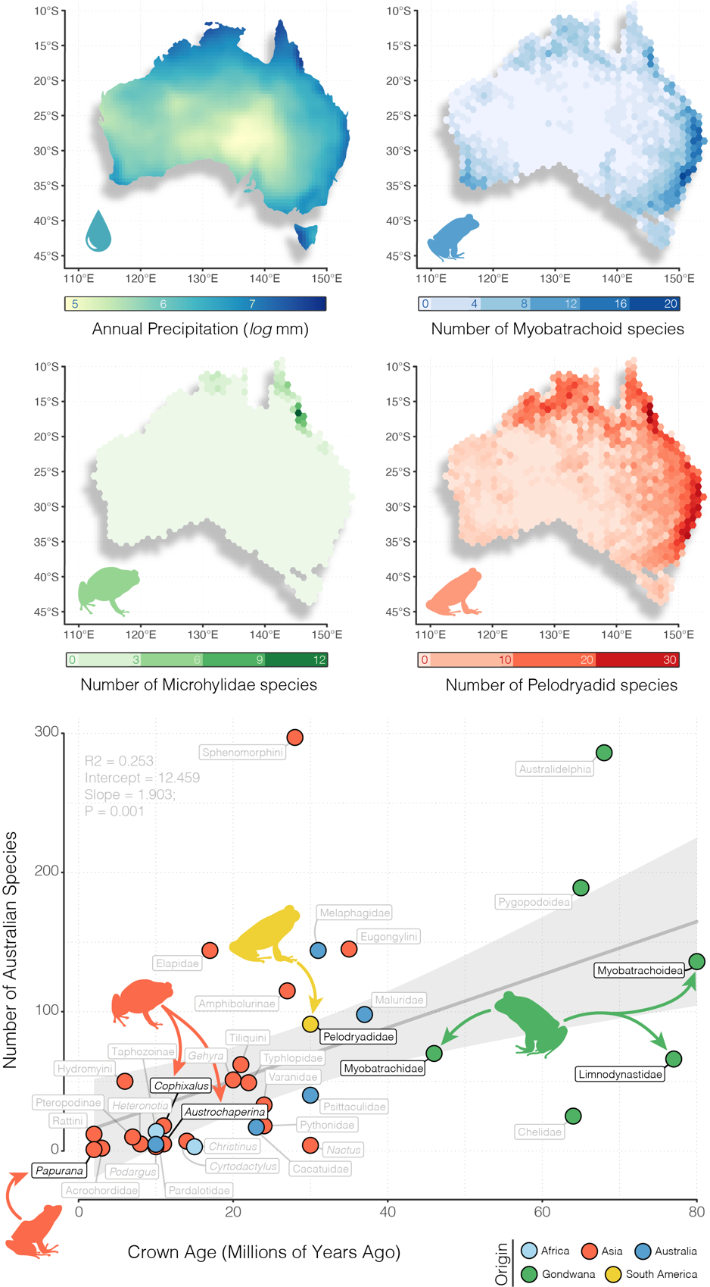

Figure 1. Australian frogs show a pattern of increasing species richness with precipitation, and with time. Above, maps of richness for the three focal radiations (with Limnodynastidae and Myobatrachidae presented together as Myobatrachoidea) are plotted alongside a map showing total annual precipitation. Greatest richness is concentrated along Australia’s east coast, however this pattern falls away in cold areas of the far southeast, particularly in southwest Tasmania. Species occurrence records were collated from the Atlas of Living Australia (https://ala.org.au). Below, Australian radiations can be divided broadly into (1) relictual Gondwanan clades >40 myo (green), (2) ancient colonizing groups (>20 myo, <40 myo; varied colors), or (3) immigrant clades of Asian origin (orange). Each point is colored according to the region of hypothesized origin and labeled by the narrowest phylogenetic taxonomy. Black labels indicate focal groups and grey labels indicate other Australian vertebrate clades. Regression in background is fit to all points and shows a general pattern of increasing species richness with age.

*Discussion*

Here we present the first reliable estimates of relationships among all of Australia’s frog genera and major clades of the mega-genus *Litoria*. Our investigation into the timing and origins of the Australian frog fauna reveals that each radiation originated or arrived during different periods in Australia’s history, demonstrating a staggered colonization and population of the continent. This stratified arrival means each radiation established itself in a very different incarnation of the continent. Across these eras Australia has flourished through a warm and wet Eocene, cooling and drying following the onset of Antarctic glaciation in the Oligocene, warm and forested Miocene, and a gradual aridification leading to its present status (Byrne et al. 2011, Pross et al. 2012, Macphail & Hill 2018, Mao & Retallack 2019).

*Origins and Biogeography*

The Myobatrachidae and Limnodynastidae (together—myobatrachoids) represent the oldest, most diverse (136 spp.), and only near-endemic of Australia’s frog radiations (one species—*Lechriodus aganoposis* is found in New Guinea). They share a long history with South America and its Gondwanan past. Anchored by a deep split with the South American *Calyptocephallela* (roughly 100 mya; Fig.2)*,* early divergences among the Australian myobatrachoids, principally between myobatrachids and limnodynastids, occurred in the late Cretaceous (80–70 mya), preceding the isolation of Australia from Antarctica. This dates to a time when South America, Antarctica, and Australia were a continuous landmass that was likely temperate in climate (Palazzesi & Barreda 2007; Mörs et al. 2020). The phylogenetic depth and distribution of myobatrachoids (including *Calyptocephallela*) across these now widely disjunct continents suggests a historically continuous distribution across southern Gondwana, including Antarctica. This idea is supported by the recent discovery of an extinct calyptocephallelid from mid-Miocene Antarctica that lived more than 40 mya (Mörs et al. 2020). The persistence of calyptocephallelids in Antarctica into the Late Eocene highlights the dichotomy between young extant myobatrachid and limnodynastid diversity (most species < 30 mya) and ancient splits between limnodynastids and myobatrachids and within limnodynastids (> 70 mya). These long branches are likely the survivors of a much greater southern Gondwanan myobatrachoid diversity, potentially mirroring the diversity of extinct calyptocephallelids through southern South America and Patagonia (Nicoli et al. 2022).

Australian myobatrachoids however are not the only group with close connections to South America. The Pelodryadidae are a species rich (91 spp.) and morphologically diverse clade of Australasian frogs. Embedded within the primarily Neotropical treefrogs, they show a more recent late-Eocene divergence from their South American relatives the Phyllomedusidae, some 40 mya. Crown divergence of the pelodryadids occurred in the mid-to-late Oligocene (30 mya) before erupting into a radiation across Australia and New Guinea in the early Miocene. This timing has spurred speculation about the origins of pelodryadids either as part of a young Gondwanan group or more recent over-water dispersers from South America (Pyron 2014). Divergence between phyllomedusids and pelodryadids 40 mya aligns with the opening of the Drake Passage and separation of South America from Antarctica (Toumoulin 2020). Unfortunately this does not provide any certainty about how pelodryadids arrived in Australia. While the Brazil Current would have provided a favorable trajectory for rafting frogs, the over-water distance between South America and Australia remained immense. A more likely scenario is that pelodryadids dispersed from South America through Antarctica and into Australia. Climate reconstructions suggest warm temperate/tropical habitats across Antarctica which would have been suitable through a long period of the Eocene (Pross et al. 2012). Dispersal via Antarctic land bridges would have had to occur prior to the Eocene-Oligocene cooling (34 mya) that blanketed Antarctica beneath an ice sheet (van den Ende et al. 2017).

Contrasting with the comparatively ancient limnodynastids, myobatrachids, and pelodryadids, Australia’s youngest anuran radiation are the microhylids. Embedded deeply in the Asterophryinae subfamily, the two temporally adjacent clades (12–13 mya) of *Austrochaperina* and *Cophixalus* crossed the gap from New Guinea to Australia in the mid Miocene. This time frame coincides with a period of increased variation in sea surface levels driven by cooling global temperatures following the mid Miocene climatic optimum. Dropping sea levels likely repeatedly exposed a landbridge between southern New Guinea and northern Australia (both Cape York and the Top End) and facilitated biotic exchange between these landmasses (Mitchell et al. 2014). The young age of these clades, and existence of two other species-rich incumbent frog clades in the pelodryadids and myobatrachoids potentially explains why Australian microhylids are relatively species poor (*Austrochaperina*—5 spp., *Cophixalus*—18 spp.) and morphologically conservative compared to their New Guinean neighbors (200+ spp.), reflecting a pattern seen in monitor lizards (Pavón-Vázquez et al. 2021).

The sole Australian ranid *Papurana daemeli* is native but not endemic to the continent, and can be found broadly across Australo-Papua, extending to just beyond the edge of the Sahul shelf (Reilly et al. 2022). It belongs to a clade of frogs distributed throughout southeast Asia, Wallacea, and Sahul, with other *Papurana* species found in New Guinea and the Solomon Islands (Oliver et al. 2015; Chan et al. 2020). Though not included in our phylogenomic sampling, *Papurana daemeli* is likely a relatively young species (<7 mya) with limited divergence between populations found in Wallacea and Sahul (Reilly et al. 2022). The broad distribution of *P. daemeli* across Australo-Papua suggests either a very recent colonization of Australia or vicariant speciation followed by subsequent dispersal out of Australia and back into New Guinea and Wallacea.

The staggered temporal origins of Australian frogs exemplifies the general colonization history of Australian vertebrates. Radiations of mammals, birds, frogs, and reptiles fall into discretized temporal groups broadly identified as (1) Gondwanan relics >40 myo, (2) old colonizers (>20 myo, <40 myo) with varied origins, or (3) recent Asian immigrants (<20 myo). The Limnodynastidae and Myobatrachidae fall undoubtedly into the Gondwanan group alongside ancient Australian radiations like Australidelphian marsupial mammals which include koalas, kangaroos, and Tasmanian devils; side-necked chelid turtles; and pygopodoid geckos which include the bizarre limbless pygopodids. These groups—with the exception of pygopodoids—have close links to South American relatives based on molecular and fossil evidence (Georges et al. 1999; Mitchell et al. 2014). While a Pelodryadidae link with South America is clear, they are perhaps the sole radiation to have emigrated from South America to Australia since the continental breakup. Most other similarly aged Australian groups instead show signal of Asian or Australian origins. In comparison, the Australian microhylids (*Austrochaperina*, *Cophixalus*) and the ranid *Papurana daemeli* are relatively young colonizers from New Guinea with deeper origins in Asian groups. Both the Asterophryinae and Ranidae, to which these species belong, have a long history in the Sunda and Wallacean regions, reflecting patterns of old diversity in this tectonically active area. Alongside a number of other groups such as pythons (Esquerré et al. 2020), monitor lizards (Brennan et al. 2021), honeyeater birds (Marki et al. 2017), dragon lizards (Tallowin et al. 2020), elapid snakes (Keogh 1998), various gekkonid gecko genera (Heinicke et al. 2011), megabats, frogmouth birds (Oliver et al. 2020), cockatoos and parrots (Schweizer et al. 2011), several skink subfamilies (Skinner et al. 2011), and two rodent groups (Roycroft et al. 2020), they share diversity across Australia and New Guinea with repeated exchange between the two islands. Many of these groups show a telltale stepping stone biogeographic pattern that links them back to mainland Asian ancestors, with Australo-Papuan members deeply phylogenetically nested. In general, these Australian clades show a pattern of increasing species richness with clade age, however the drivers of such a pattern are likely idiosyncratic (Fig.1).

*Macroevolutionary Patterns*

The radiation of frogs in Australia has occurred over a deep timescale and across a changing climatic landscape. Old species-poor lineages have become confined to the mesic-temperate fringes of the continent, while new niches and species have popped up in the expanding arid zone. And while frogs are found across most of the Australian continent, their basic moisture requirements and desiccation sensitivity mean that Australian amphibian diversity shows a stark mesic-arid gradient (Fig.1), similar to that seen for birds and mammals, and the inverse of lizards (Powney et al. 2010). Not all has been lost in the red center though—several independent clades of dry-country inhabitants have evolved among Australia’s harsh sandy and stony deserts. *Neobatrachus*, *Notaden,* and *Cyclorana* have all evolved to aestivate through the hottest and driest seasons. These genera(commonly known as the water-holding frogs) are capable of growing epidermal cocoons to retain moisture that may see them through periods of extreme drought lasting from months to years (van Beurden 1980).

Along with changes in habitat and ecology, Australia’s frogs have also accumulated vast diversity in reproductive strategy, ontogenetic trajectory, and morphology (Crump 2015, Duellman 1992, Sherratt et al. 2018). While we do not present data on these topics, our well-resolved phylogenetic hypothesis provides new context for the macroevolution of some of these extreme traits. Bizarre rearing habits such as raising young in stomachs (*Rheobatrachus*), hip-pockets (*Assa*), or subterranean nests (*Myobatrachus*) exist on both long branches and deeply nested taxa suggesting a remarkable frequency of transition among states. Similarly, morphological variation has rapidly evolved to dramatic extremes. The long limbed highly aquatic *Litoria dahlii* with webbed feet and dorsally situated eyes is sister to the short-limbed burrowing water-holding frogs *Cyclorana* (Vidal-Garcia & Keogh 2015). Together these frogs are embedded deeply within the otherwise toe-padded and arboreal tree frogs, highlighting the adaptive capacity of pelodryadids. Myobatrachoids too have taken ecomorphology to the extreme, offering us what is perhaps the world’s strangest living anuran,the turtle frog *Myobatrachus gouldii*. In pursuit of their backwards burrowing lifestyle and termite-heavy diet, *Myobatrachus* lack many of the characteristics we typically associate with frogs. Their beady black eyes are set in small heads and, alongside their sister taxon *Arenophryne,* they crawl—not jump—across the ground on short limbs that are incapable of hopping (Vidal-Garcia et al. 2014).

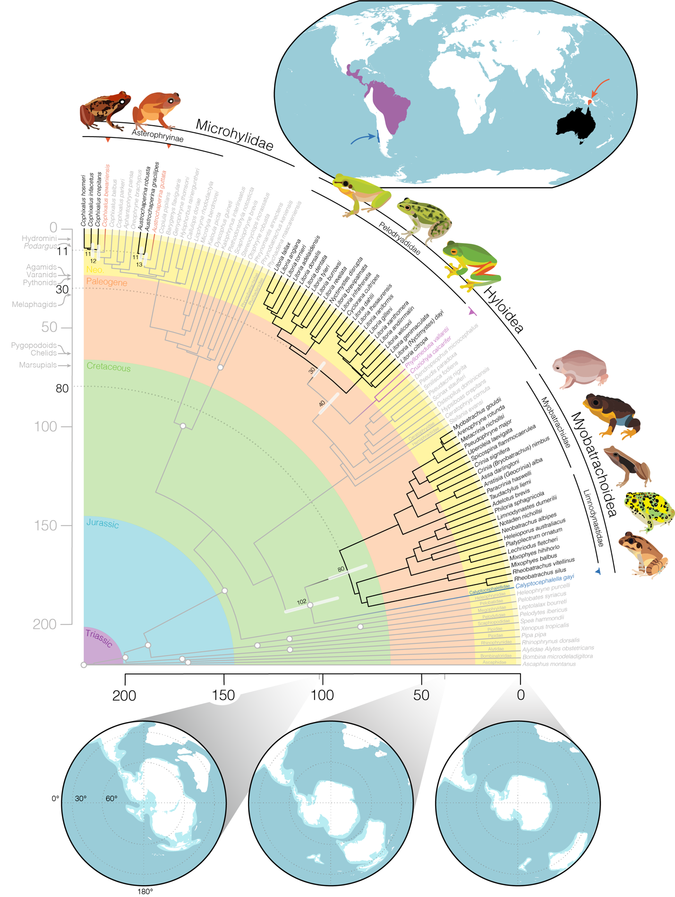

Figure 2. Time-calibrated frog phylogeny highlights the varied origins and staggered arrival of the four major frog families that comprise the Australian anuran fauna. Primarily Australian clades are identified by black branches and text, their closest living relatives outside of Australia are noted by colored branches and text, and outgroup taxa are grey. White circles at nodes identify the location of fossil calibrations (see Table S2). Upper inset map shows the general geographic location of: (red) closely related microhylids in New Guinea, (purple) phyllomedusid hylids in South America, and (dark blue) *Calyptocephallela* in Chile. Lower inset maps show the connection and proximity of Australia to other Gondwanan continents as Australia drifted away over the past 100 million years. White indicates contemporary coastlines, light blue the continental plates, and dark blue the oceans. Maps were generated using GPlates and input files modified from Landis (2017). Partial fan phylogeny was plotted using *phytools* in the R programming environment. Annotations on vertical time axis show the age of crown divergences of other notable Australian groups for temporal context (see Fig.1). Species illustrated clockwise from top left: *Cophixalus infacetus, Austrochaperina robusta, Litoria fallax, Litoria dahlii, Litoria xanthomera, Myobatrachus gouldii, Spicospina flammocaerulea, Taudactylus acutirostris, Notaden bennettii, Mixophyes balbus.*

*Conclusion*

Australian frogs offer important insights into colonization, persistence, and diversification of a major continental group through deep time. The varied species richness, timing of diversification, and ecomorphological diversity among replicate radiations provides evidence of the processes dictating the accumulation of biodiversity. Beyond the temperate and tropical forests of the east and north coast, the Australian continent is an open country of habitat scarcely welcoming to frogs. Despite this, anurans have a long history in Australia and have diversified into an amazing array of forms, colors, and lifestyles. This success is potentially the result of the stratified temporal arrival of the three main frog clades and possibly exaggerated by their ecological differences. Our phylogenetic framework provides a foundation for examining how temporal changes to climate, habitat, and niche space have influenced the diversification of one of Australia’s richest and most unique vertebrate faunas.

*Data Accessibility*

Sequence alignments, analysis control files, and phylogenetic trees can be downloaded from Dryad: *link to be updated upon submission*.

*Acknowledgments*

Thank you to the curators and staff of the many Australian museums and colleagues for access to tissues and locality information, and to the technical staff at our institutions for support and generating the genetic data that made this work possible. JSK, CJH, and SCD thank the Australian Research Council for ongoing support.

References

AmphibiaWeb. (2022). *AmphibiaWeb: Information on amphibian biology and conservation*.

Anstis, M. (2017). *Tadpoles and frogs of Australia*. New Holland Publishers Pty Limited.

Benoit, M., Drost, H. G. (2021). [A Predictive Approach to Infer the Activity and Natural Variation of Retrotransposon Families in Plants](https://link.springer.com/protocol/10.1007%2F978-1-0716-1134-0_1). In: Cho J. (eds) Plant Transposable Elements. *Methods in Molecular Biology*, vol 2250. Humana, New York, NY.

Bijl, P. K., Bendle, J. A., Bohaty, S. M., Pross, J., Schouten, S., Tauxe, L., Stickley C. E., McKay, R. M., Röhl, U., Olney, M., Sluijs, A., Escutia, C., Brinkhuis, H., & Expedition 318 Scientists. (2013). Eocene cooling linked to early flow across the Tasmanian Gateway. *Proceedings of the National Academy of Sciences*, *110*(24), 9645-9650.

Borowiec, M. L. (2016). AMAS: a fast tool for alignment manipulation and computing of summary statistics. *PeerJ*, *4*, e1660.

Brennan, I. G., Lemmon, A. R., Lemmon, E. M., Portik, D. M., Weijola, V., Welton, L., Donnellan, S. C., & Keogh, J. S. (2021). Phylogenomics of monitor lizards and the role of competition in dictating body size disparity. *Systematic Biology*, *70*(1), 120-132.

Byrne, M., Steane, D. A., Joseph, L., Yeates, D. K., Jordan, G. J., Crayn, D., ... & Weston, P. H. (2011). Decline of a biome: evolution, contraction, fragmentation, extinction and invasion of the Australian mesic zone biota. *Journal of biogeography*, *38*(9), 1635-1656.

Chan, K. O., Hutter, C. R., Wood Jr, P. L., Grismer, L. L., & Brown, R. M. (2020). Larger, unfiltered datasets are more effective at resolving phylogenetic conflict: Introns, exons, and UCEs resolve ambiguities in Golden-backed frogs (Anura: Ranidae; *Hylarana*). *Molecular phylogenetics and evolution*, *151*, 106899.

Crump, M. L. (2015). Anuran reproductive modes: evolving perspectives. *Journal of Herpetology*, *49*(1), 1-16.

dos Reis, M. & Yang, Z. (2011). Approximate likelihood calculation for Bayesian estimation of divergence times. Molecular Biology and Evolution, 28:2161-2172.

Duellman, W. E. (1992). Reproductive strategies of frogs. *Scientific American*, *267*(1), 80-87.

Esquerré, D., Donnellan, S., Brennan, I. G., Lemmon, A. R., Moriarty Lemmon, E., Zaher, H., Grazziotin, F. G., & Keogh, J. S. (2020). Phylogenomics, biogeography, and morphometrics reveal rapid phenotypic evolution in pythons after crossing Wallace’s line. *Systematic Biology*, *69*(6), 1039-1051.

Feng, Y. J., Blackburn, D. C., Liang, D., Hillis, D. M., Wake, D. B., Cannatella, D. C., & Zhang, P. (2017). Phylogenomics reveals rapid, simultaneous diversification of three major clades of Gondwanan frogs at the Cretaceous–Paleogene boundary. *Proceedings of the national Academy of Sciences*, *114*(29), E5864-E5870.

Georges, A., Birrell, J., Saint, K. M., McCord, W. P., & Donnellan, S. C. (1999). A phylogeny for side-necked turtles (Chelonia: Pleurodira) based on mitochondrial and nuclear gene sequence variation. *Biological Journal of the Linnean Society*, *67*(2), 213-246.

Hall, R. (2002). Cenozoic geological and plate tectonic evolution of SE Asia and the SW Pacific: computer-based reconstructions, model and animations. *Journal of Asian Earth Sciences*, *20*(4), 353-431.

Heinicke, M. P., Greenbaum, E., Jackman, T. R., & Bauer, A. M. (2011). Phylogeny of a trans‐Wallacean radiation (Squamata, Gekkonidae, *Gehyra*) supports a single early colonization of Australia. *Zoologica Scripta*, *40*(6), 584-602.

Hime, P. M., Lemmon, A. R., Lemmon, E. M., Prendini, E., Brown, J. M, Thomson, R. C, Kratovil, J. D, Noonan, B. P, Pyron, R A., Peloso, P. L V, Kortyna, M. L, Keogh, J. S., Donnellan, S. C, Mueller, R. L., Raxworthy, C. J, Kunte, K., Ron, S. R, Das, S., Gaitonde, N., Green, D. M, Labisko, J., Che, J., & Weisrock, D. W. (2021). Phylogenomics reveals ancient gene tree discordance in the amphibian tree of life. *Systematic Biology*, *70*(1), 49-66.

Hoskin, C. J., & Aland, K. (2011). Two new frog species (Microhylidae: *Cophixalus*) from boulder habitats on Cape York Peninsula, north-east Australia. *Zootaxa*, *3027*(1), 39-51.

Hoskin, C. J. (2013). A new frog species (Microhylidae: *Cophixalus*) from boulder-pile habitat of Cape Melville, north-east Australia. *Zootaxa*, *3722*, 61-72.

Kalyaanamoorthy, S., Minh, B. Q., Wong, T. K., Von Haeseler, A., & Jermiin, L. S. (2017). ModelFinder: fast model selection for accurate phylogenetic estimates. *Nature methods*, *14*(6), 587-589.

Katoh, K., & Standley, D. M. (2013). MAFFT multiple sequence alignment software version 7: improvements in performance and usability. *Molecular biology and evolution*, *30*(4), 772-780.

Keogh, J. S. (1998). Molecular phylogeny of elapid snakes and a consideration of their biogeographic history. *Biological journal of the Linnean Society*, *63*(2), 177-203.

Landis, M. J. (2017). Biogeographic dating of speciation times using paleogeographically informed processes. *Systematic Biology*, *66*(2), 128-144.

Lemmon, A. R., Emme, S. A., & Lemmon, E. M. (2012). Anchored hybrid enrichment for massively high-throughput phylogenomics. *Systematic Biology*, *61*(5), 727-744.

Macphail, M. K., & Hill, R. S. (2018). What was the vegetation in northwest Australia during the Paleogene, 66–23 million years ago?. *Australian Journal of Botany*, *66*(7), 556-574.

Mao, X., & Retallack, G. (2019). Late Miocene drying of central Australia. *Palaeogeography, Palaeoclimatology, Palaeoecology*, *514*, 292-304.

Marki, P. Z., Jønsson, K. A., Irestedt, M., Nguyen, J. M., Rahbek, C., & Fjeldså, J. (2017). Supermatrix phylogeny and biogeography of the Australasian Meliphagides radiation (Aves: Passeriformes). *Molecular phylogenetics and Evolution*, *107*, 516-529.

Minh, B. Q., Nguyen, M. A. T., & von Haeseler, A. (2013). Ultrafast approximation for phylogenetic bootstrap. *Molecular Biology and Evolution*, *30*(5), 1188-1195.

Mitchell, K. J., Pratt, R. C., Watson, L. N., Gibb, G. C., Llamas, B., Kasper, M., ... & Cooper, A. (2014). Molecular phylogeny, biogeography, and habitat preference evolution of marsupials. *Molecular biology and evolution*, *31*(9), 2322-2330.

Mörs, T., Reguero, M., Vasylan, D., (2020). First fossil frog from Antarctica: implications for Eocene high latitude climate conditions and Gondwanan cosmopolitanism of Australobatrachia. *Scientific Reports* 10, 5051.

Nicoli, L., Muzzopappa, P., Espinoza, N., & Melchor, R. (2022). A new fossil species of Calyptocephalella (Anura: Australobatrachia) from the Miocene of northern Patagonia: Novel evidence of the broad past diversity of the genus. *Journal of South American Earth Sciences*, *119*, 104008.

Nguyen, L. T., Schmidt, H. A., Von Haeseler, A., & Minh, B. Q. (2015). IQ-TREE: a fast and effective stochastic algorithm for estimating maximum-likelihood phylogenies. *Molecular biology and evolution*, *32*(1), 268-274.

Oliver, L. A., Prendini, E., Kraus, F., & Raxworthy, C. J. (2015). Systematics and biogeography of the *Hylarana* frog (Anura: Ranidae) radiation across tropical Australasia, Southeast Asia, and Africa. *Molecular Phylogenetics and Evolution*, *90*, 176-192.

Oliver, P. M., Heiniger, H., Hugall, A. F., Joseph, L., & Mitchell, K. J. (2020). Oligocene divergence of frogmouth birds (Podargidae) across Wallace's Line. *Biology Letters*, *16*(5), 20200040.

Palazzesi, L., Barreda, V., (2007). Major vegetation trends in the Tertiary of Patagonia (Argentina): a qualitative paleoclimatic approach based on palynological evidence. *Flora-Morphol. Distrib. Funct. Ecol. Plants* 202, 328–337.

Pavón-Vázquez, C. J., Brennan, I. G., Skeels, A., & Keogh, J. S. (2022). Competition and geography underlie speciation and morphological evolution in Indo‐Australasian monitor lizards. *Evolution*, *76*(3), 476-495.

Powney, G. D., Grenyer, R., Orme, C. D. L., Owens, I. P. F., & Meiri, S. (2010). Hot, dry and different: Australian lizard richness is unlike that of mammals, amphibians and birds. *Global Ecology and Biogeography*, *19*(3), 386-396.

Pross J, Contreras L, Bijl PK, Greenwood DR, Bohaty SM, Schouten S, Bendle JA, Röhl U, Tauxe L, Raine JI, Huck CE, van de Flierdt T, Jamieson SSR, Stickley CE, van de Schootbrugge B, Escutia C, Brinkhuis H Integrated Ocean Drilling Program Expedition 318 Scientists. (2012). Persistent near-tropical warmth on the Antarctic continent during the early Eocene epoch. *Nature* 488, 73–77.

Pyron, R. A. (2014). Biogeographic analysis reveals ancient continental vicariance and recent oceanic dispersal in amphibians. *Systematic Biology*, *63*(5), 779-797.

Rannala, B., Yang, Z. (2007) Inferring speciation times under an episodic molecular clock. *Systematic Biology*, 56:453-466.Sherratt, E., Vidal-García, M., Anstis, M., & Keogh, J. S. (2017). Adult frogs and tadpoles have different macroevolutionary patterns across the Australian continent. *Nature Ecology & Evolution*, *1*(9), 1385-1391.

Reilly, S. B., Arifin, U., Stubbs, A. L., Karin, B. R., Kaiser, H., Frederick, J. H., Arida, E., Iskandar, D. T., McGuire, J. A. (2022). Phylogenetic relationships of southern Wallacean ranid frogs (Anura: Ranidae: *Hylarana*). *Zootaxa*, *5150*(4), 591-599.

Roycroft, E. J., Moussalli, A., & Rowe, K. C. (2020). Phylogenomics uncovers confidence and conflict in the rapid radiation of Australo-Papuan rodents. *Systematic Biology*, *69*(3), 431-444.

Schweizer, M., Seehausen, O., & Hertwig, S. T. (2011). Macroevolutionary patterns in the diversification of parrots: effects of climate change, geological events and key innovations. *Journal of Biogeography*, *38*(11), 2176-2194.

Sherratt, E., Anstis, M., & Keogh, J. S. (2018). Ecomorphological diversity of Australian tadpoles. *Ecology and evolution*, *8*(24), 12929-12939.

Skinner, A., Hugall, A. F., & Hutchinson, M. N. (2011). Lygosomine phylogeny and the origins of Australian scincid lizards. *Journal of Biogeography*, *38*(6), 1044-1058.

Tallowin, O. J., Meiri, S., Donnellan, S. C., Richards, S. J., Austin, C. C., & Oliver, P. M. (2020). The other side of the Sahulian coin: biogeography and evolution of Melanesian forest dragons (Agamidae). *Biological Journal of the Linnean Society*, *129*(1), 99-113.

Toumoulin, A., Donnadieu, Y., Ladant, JB, Batenburg, SJ, Poblete, F., & Dupont, Nivet, G. (2020). Quantifying the effect of the Drake Passage opening on the Eocene Ocean. *Paleoceanography and Paleoclimatology*, *35* (8), e2020PA003889.

Tyler, M. J. (1998). *Australian frogs: a natural history*. Cornell University Press.

van Beurden, E. K. (1980). Energy Metabolism of Dormant Australian Water-Holding Frogs (Cyclorana platycephalus). *Copeia*, 1980(4), 787–799.

Van Den Ende, C., White, L. T., & van Welzen, P. C. (2017). The existence and break-up of the Antarctic land bridge as indicated by both amphi-Pacific distributions and tectonics. *Gondwana Research*, *44*, 219-227.

Vidal-García, M., Byrne, P. G., Roberts, J. D., & Keogh, J. S. (2014). The role of phylogeny and ecology in shaping morphology in 21 genera and 127 species of Australo-Papuan myobatrachid frogs. *Journal of Evolutionary Biology*, *27*(1), 181-192.

Vidal-García, M., & Keogh, J. S. (2015). Convergent evolution across the Australian continent: ecotype diversification drives morphological convergence in two distantly related clades of Australian frogs. *Journal of Evolutionary Biology*, *28*(12), 2136-2151.

Zhang, C., Rabiee, M., Sayyari, E., & Mirarab, S. (2018). ASTRAL-III: polynomial time species tree reconstruction from partially resolved gene trees. *BMC bioinformatics*, *19*(6), 15-30.

*Figure Captions*

Figure 1. Australian frogs show a pattern of increasing species richness with precipitation, and with time. Above, maps of richness for the three focal radiations (with Limnodynastidae and Myobatrachidae presented together as Myobatrachoidea) are plotted alongside a map showing total annual precipitation. Greatest richness is concentrated along Australia’s east coast, however this pattern falls away in cold areas of the far southeast, particularly in southwest Tasmania. Species occurrence records were collated from the Atlas of Living Australia (https://ala.org.au). Below, Australian radiations can be divided broadly into (1) relictual Gondwanan clades >40 myo (green), (2) ancient colonizing groups (>20 myo, <40 myo; varied colors), or (3) immigrant clades of Asian origin (orange). Each point is colored according to the region of hypothesized origin and labeled by the narrowest phylogenetic taxonomy. Black labels indicate focal groups and grey labels indicate other Australian vertebrate clades. Regression in background is fit to all points and shows a general pattern of increasing species richness with age.

Figure 2. Time-calibrated frog phylogeny highlights the varied origins and staggered arrival of the four major frog families that comprise the Australian anuran fauna. Primarily Australian clades are identified by black branches and text, their closest living relatives outside of Australia are noted by colored branches and text, and outgroup taxa are grey. White circles at nodes identify the location of fossil calibrations (see Table S2). Upper inset map shows the general geographic location of: (red) closely related microhylids in New Guinea, (purple) phyllomedusid hylids in South America, and (dark blue) *Calyptocephallela* in Chile. Lower inset maps show the connection and proximity of Australia to other Gondwanan continents as Australia drifted away over the past 100 million years. White indicates contemporary coastlines, light blue the continental plates, and dark blue the oceans. Maps were generated using GPlates and input files modified from Landis (2017). Partial fan phylogeny was plotted using *phytools* in the R programming environment. Annotations on vertical time axis show the age of crown divergences of other notable Australian groups for temporal context (see Fig.1). Species illustrated clockwise from top left: *Cophixalus infacetus, Austrochaperina robusta, Litoria fallax, Litoria dahlii, Litoria xanthomera, Myobatrachus gouldii, Spicospina flammocaerulea, Taudactylus acutirostris, Notaden bennettii, Mixophyes balbus.*

Supplementary Materials

Data available from the Dryad Digital Repository: http://dx.doi.org/10.5061/dryad.[NNNN]

Table S1. Taxon sampling for this project.

|  |  |  |  |  |  |
| --- | --- | --- | --- | --- | --- |
| Geography | Superfamily/Clade | Family | Subfamily | Genus species | Registration |
| Outgroup | Pipoidea | Pipidae | ⁠— | *Xenopus tropicalis* | NCBI Genome |
| Outgroup | Pipoidea | Pipidae | ⁠— | *Pipidae Pipa pipa* | MVZ 247511 |
| Outgroup | Pipoidea | Rhinophrynidae | ⁠— | *Rhinophrynus dorsalis* | MVZ 164756 |
| Outgroup | Leiopelmatoidea | Ascaphidae | ⁠— | *Ascaphus montanus* | REF AscMon |
| Outgroup | Discoglossoidea | Bombinatoridae | ⁠— | *Bombina microdeladigitora* | CAS 242112 |
| Outgroup | Discoglossoidea | Alytidae | ⁠— | *Alytes obstetricans* | MVZ 231914 |
| Outgroup | Pelobatoidea | Scaphiopodidae | ⁠— | *Spea hammondii* | MVZ 145187 |
| Outgroup | Pelobatoidea | Pelodytidae | ⁠— | *Pelodytes ibericus* | MVZ 186009 |
| Outgroup | Pelobatoidea | Megophryidae | ⁠— | *Leptolalax bourreti* | AMCC 106489 |
| Outgroup | Pelobatoidea | Pelobatidae | ⁠— | *Pelobates syriacus* | MVZ 234650 |
| Outgroup | ⁠— | Heleophrynidae | ⁠— | *Heleophryne purcelli* | SANBI 1954 |
| Outgroup | Ranoidea | Ptychadenidae | ⁠— | *Ptychadena mascareniensis* | ESP/CJR R1068 |
| Outgroup | Ranoidea | Phrynobatrachidae | ⁠— | *Phrynobatrachus keniensis* | MVZ 226261 |
| Outgroup | Ranoidea | Microhylidae | Phrynomatinae | *Phrynomantis annectens* | ESP/CJR R1330 |
| Outgroup | Ranoidea | Microhylidae | Otophryinae | *Otophryne robusta* | PLVP PT459 |
| Outgroup | Ranoidea | Microhylidae | Gastrophryinae | *Stereocyclops incrassatus* | PLVP PT273 |
| Outgroup | Ranoidea | Microhylidae | Scaphiophryinae | *Scaphiophryne brevis* | PLVP PT312 |
| Outgroup | Ranoidea | Microhylidae | Cophylinae | *Plethodontohyla notosticta* | AMCC 128714 |
| Outgroup | Ranoidea | Microhylidae | Kalophryinae | *Kalophrynus interlineatus* | ABTC 105933 |
| Outgroup | Ranoidea | Microhylidae | Dyscophinae | *Dyscophus guineti* | MVZ 238744 |
| Outgroup | Ranoidea | Microhylidae | Microhylinae | *Kaloula picta* | ABTC 76311 |
| Outgroup | Ranoidea | Microhylidae | Microhylinae | *Microhyla berdmorei* | ABTC 106005 |
| Outgroup | Ranoidea | Microhylidae | Asterophryinae | *Liophryne rhododactyla* | ABTC 49542 |
| Outgroup | Ranoidea | Microhylidae | Asterophryinae | *Callulops doriae* | ABTC 98415 |
| Outgroup | Ranoidea | Microhylidae | Asterophryinae | *Hylophorbus rainerguntheri* | ABTC 98304 |
| Outgroup | Ranoidea | Microhylidae | Asterophryinae | *Genyophryne thomsoni* | PLVP PT452 |
| Outgroup | Ranoidea | Microhylidae | Asterophryinae | *Barygenys flavigularis* | PLVP PT439 |
| Outgroup | Ranoidea | Microhylidae | Asterophryinae | *Copiula pipilans* | ABTC 114698 |
| Outgroup | Ranoidea | Microhylidae | Asterophryinae | *Austrochaperina guttata* | ABTC 141506 |
| Australian Clade | Ranoidea | Microhylidae | Asterophryinae | *Austrochaperina gracilipes* | ABTC 79186 |
| Australian Clade | Ranoidea | Microhylidae | Asterophryinae | *Austrochaperina robusta* | conx5153 |
| Outgroup | Ranoidea | Microhylidae | Asterophryinae | *Oreophryne brachypus* | ABTC 104804 |
| Outgroup | Ranoidea | Microhylidae | Asterophryinae | *Aphantophryne pansa* | ABTC 49605 |
| Outgroup | Ranoidea | Microhylidae | Asterophryinae | *Cophixalus parkeri* | ABTC 49557 |
| Outgroup | Ranoidea | Microhylidae | Asterophryinae | *Cophixalus balbus* | ABTC 114884 |
| Outgroup | Ranoidea | Microhylidae | Asterophryinae | *Cophixalus bewaniensis* | ABTC 112107 |
| Australian Clade | Ranoidea | Microhylidae | Asterophryinae | *Cophixalus crepitans* | conx1112 |
| Australian Clade | Ranoidea | Microhylidae | Asterophryinae | *Cophixalus infacetus* | conx5295 |
| Australian Clade | Ranoidea | Microhylidae | Asterophryinae | *Cophixalus hosmeri* | conx5267 |
| Outgroup | Myobatrachoidea | Calyptocephalellidae | ⁠— | *Calyptocephalella gayi* | PMH 1 |
| Australian Clade | Myobatrachoidea | Rheobatrachidae | ⁠— | *Rheobatrachus silus* | ABTC 7324 |
| Australian Clade | Myobatrachoidea | Rheobatrachidae | ⁠— | *Rheobatrachus vitellinus* | ABTC 105698 |
| Australian Clade | Myobatrachoidea | Mixophyidae | ⁠— | *Mixophyes balbus* | ABTC 25323 |
| Australian Clade | Myobatrachoidea | Mixophyidae | ⁠— | *Mixophyes hihihorlo* | ABTC 45861 |
| Australian Clade | Myobatrachoidea | Limnodynastidae | ⁠— | *Lechriodus fletcheri* | ABTC 24892 |
| Australian Clade | Myobatrachoidea | Limnodynastidae | ⁠— | *Opisthodon ornatus* | ABTC 15543 |
| Australian Clade | Myobatrachoidea | Limnodynastidae | ⁠— | *Heleioporus australiacus* | ABTC 67742 |
| Australian Clade | Myobatrachoidea | Limnodynastidae | ⁠— | *Neobatrachus albipes* | ABTC 15833 |
| Australian Clade | Myobatrachoidea | Limnodynastidae | ⁠— | *Notaden nichollsi* | ABTC 15833 |
| Australian Clade | Myobatrachoidea | Limnodynastidae | ⁠— | *Limnodynastes dumerilii* | ABTC 104299 |
| Australian Clade | Myobatrachoidea | Limnodynastidae | ⁠— | *Philoria sphagnicola* | ABTC 25832 |
| Australian Clade | Myobatrachoidea | Limnodynastidae | ⁠— | *Adelotus brevis* | ABTC 24210 |
| Australian Clade | Myobatrachoidea | Myobatrachidae | ⁠— | *Taudactylus liemi* | ABTC 50947 |
| Australian Clade | Myobatrachoidea | Myobatrachidae | ⁠— | *Paracrinia haswelli* | ABTC 26441 |
| Australian Clade | Myobatrachoidea | Myobatrachidae | ⁠— | *Geocrinia alba* | ABTC 106079 |
| Australian Clade | Myobatrachoidea | Myobatrachidae | ⁠— | *Assa darlingtoni* | ABTC 136278 |
| Australian Clade | Myobatrachoidea | Myobatrachidae | ⁠— | *Bryobatrachus nimbus* | ABTC 25297 |
| Australian Clade | Myobatrachoidea | Myobatrachidae | ⁠— | *Crinia signifera* | ABTC 25676 |
| Australian Clade | Myobatrachoidea | Myobatrachidae | ⁠— | *Spicospina flammocaerulea* | ABTC 144371 |
| Australian Clade | Myobatrachoidea | Myobatrachidae | ⁠— | *Uperoleia laevigata* | MM 1227 |
| Australian Clade | Myobatrachoidea | Myobatrachidae | ⁠— | *Pseudophryne major* | ABTC 16479 |
| Australian Clade | Myobatrachoidea | Myobatrachidae | ⁠— | *Metacrinia nichollsi* | ABTC 17124 |
| Australian Clade | Myobatrachoidea | Myobatrachidae | ⁠— | *Arenophryne rotunda* | ABTC 114066 |
| Australian Clade | Myobatrachoidea | Myobatrachidae | ⁠— | *Myobatrachus gouldii* | WAM R156759 |
| Outgroup | Hyloidea | Hemiphractidae | ⁠— | *Stefania evansi* | BPN1286 |
| Outgroup | Hyloidea | Ceratophryidae | ⁠— | *Ceratophrys cornuta* | MVZ 247561 |
| Outgroup | Hyloidea | Hylidae | Cophomantinae | *Hypsiboas crepitans* | YPM 10666 |
| Outgroup | Hyloidea | Hylidae | Lophohylinae | *Osteopilus dominicensis* | MCZA148702 |
| Outgroup | Hyloidea | Hylidae | Scinaxinae | *Scinax staufferi* | MVZ 257781 |
| Outgroup | Hyloidea | Hylidae | Pseudinae | *Pseudis paradoxa* | LSUMNS 12511 |
| Outgroup | Hyloidea | Hylidae | Dendropsophinae | *Dendropsophus microcephalus* | MVZ 264263 |
| Outgroup | Hyloidea | Hylidae | Acrisinae | *Pseudacris nigrita* | REF PseNig |
| Outgroup | Hyloidea | Hylidae | Hylinae | *Smilisca fodiens* | YPM 014191 |
| Outgroup | Hyloidea | Phyllomedusidae | ⁠— | *Cruziohyla calcarifer* | QCAZ 48552 |
| Outgroup | Hyloidea | Phyllomedusidae | ⁠— | *Phyllomedusa vallantii* | QCAZ 48818 |
| Australian Clade | Hyloidea | Pelodryadidae | ⁠— | *Litoria citropa* | ABTC 7146 |
| Australian Clade | Hyloidea | Pelodryadidae | ⁠— | *Nyctimystes dayi* | ABTC 15997 |
| Australian Clade | Hyloidea | Pelodryadidae | ⁠— | *Litoria genimaculata* | ABTC 42824 |
| Australian Clade | Hyloidea | Pelodryadidae | ⁠— | *Litoria wilcoxii* | ABTC 16804 |
| Australian Clade | Hyloidea | Pelodryadidae | ⁠— | *Litoria andiirrmalin* | ABTC 142651 |
| Australian Clade | Hyloidea | Pelodryadidae | ⁠— | *Litoria xanthomera* | ABTC 102385 |
| Australian Clade | Hyloidea | Pelodryadidae | ⁠— | *Litoria gilleni* | ABTC 30786 |
| Australian Clade | Hyloidea | Pelodryadidae | ⁠— | *Litoria raniformis* | ABTC 12854 |
| Australian Clade | Hyloidea | Pelodryadidae | ⁠— | *Litoria thesaurensis* | ABTC 50489 |
| Australian Clade | Hyloidea | Pelodryadidae | ⁠— | *Litoria dahlii* | ABTC 102434 |
| Australian Clade | Hyloidea | Pelodryadidae | ⁠— | *Cyclorana cultripes* | ABTC 16892 |
| Australian Clade | Hyloidea | Pelodryadidae | ⁠— | *Litoria infrafrenata* | ABTC 86210 |
| Australian Clade | Hyloidea | Pelodryadidae | ⁠— | *Litoria brevipalmata* | ABTC 127632 |
| Australian Clade | Hyloidea | Pelodryadidae | ⁠— | *Nyctimystes disrupta* | ABTC 48225 |
| Australian Clade | Hyloidea | Pelodryadidae | ⁠— | *Litoria revelata* | ABTC 80814 |
| Australian Clade | Hyloidea | Pelodryadidae | ⁠— | *Litoria burrowsi* | ABTC 17631 |
| Australian Clade | Hyloidea | Pelodryadidae | ⁠— | *Litoria tyleri* | ABTC 3925 |
| Australian Clade | Hyloidea | Pelodryadidae | ⁠— | *Litoria balatus* | ABTC 100638 |
| Australian Clade | Hyloidea | Pelodryadidae | ⁠— | *Litoria dorsalis* | ABTC 79181 |
| Australian Clade | Hyloidea | Pelodryadidae | ⁠— | *Litoria adelaidensis* | ABTC 28282 |
| Australian Clade | Hyloidea | Pelodryadidae | ⁠— | *Litoria angiana* | ABTC 48210 |
| Australian Clade | Hyloidea | Pelodryadidae | ⁠— | *Litoria fallax* | ABTC 102409 |
| Australian Clade | Hyloidea | Pelodryadidae | ⁠— | *Litoria tornieri* | ABTC 11777 |

Table S2. Fossil calibrations implemented in MCMCtree analysis of frog divergence dates. Node number (#) corresponds to nodes in supplementary figure below.

|  |  |  |  |  |  |
| --- | --- | --- | --- | --- | --- |
| # | Node Calibrated | Fossil | Minimum | Soft Max. | Source (see Feng et al. 2017) |
| 1 | Anura | *† Liaobatrachus zhaoi* | 129.7 | 252 | Chang et al. (2009) |
| 2 | Alytoidea | *† Iberobatrachus angelae* | 125 | 252 | Gomez et al. (2016) |
| 3 | Pipanura | *† Rhadinosteus parvus* | 148.1 | 252 | Cannatella (2015) |
| 4 | Pipoidea | *† Neusibatrachus wilferti* | 127.2 | 52 | Gomez et al. (2016) |
| 5 | Pipidae | *† Pachycentra taqueti* | 83.6 | 48.1 | Cannatella (2015) |
| 6 | Pelobatoidea | *† Elkobatrachus brocki* | 46.1 | 148.1 | Henrici and Haynes (2006) |
| 7 | Pelodytes + (Pelobatidae + Megophryidae) | *† Miopelodytes gilmorei* | 38.9 | 148.1 | Henrici and Haynes (2006) |
| 8 | Pelobatidae + Megophryidae | *† Macropelobates osborni* | 28.1 | 148.1 | Cohen et al. (2013) |
| 9 | Acosmanura | *† Eurycephalella alcinae* | 113 | 252 | Baez (2009) |
| 10 | Neobatrachia | *† Beelzebufo ampinga* | 66 | 148.1 | Rogers et al. (2013) |
| 11 | Myobatrachoidea | *† Calyptocephalella pichileufensis* | 47.5 | 48.1 | Gomez et al. (2011) |
| 12 | Ranoidea | *† Thamastosaurus gezei* | 33.9 | 148.1 | Rage and Rocek (2007) |
| 13 | Ptychadena + Phrynobatrachus | *Ptychadenidae fossil* | 25 | 148.1 | Blackburn et al. (2015) |

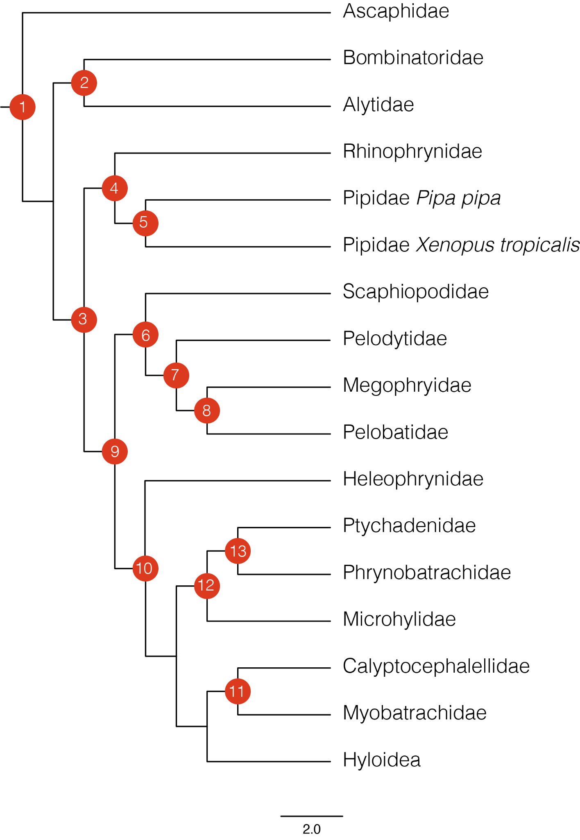

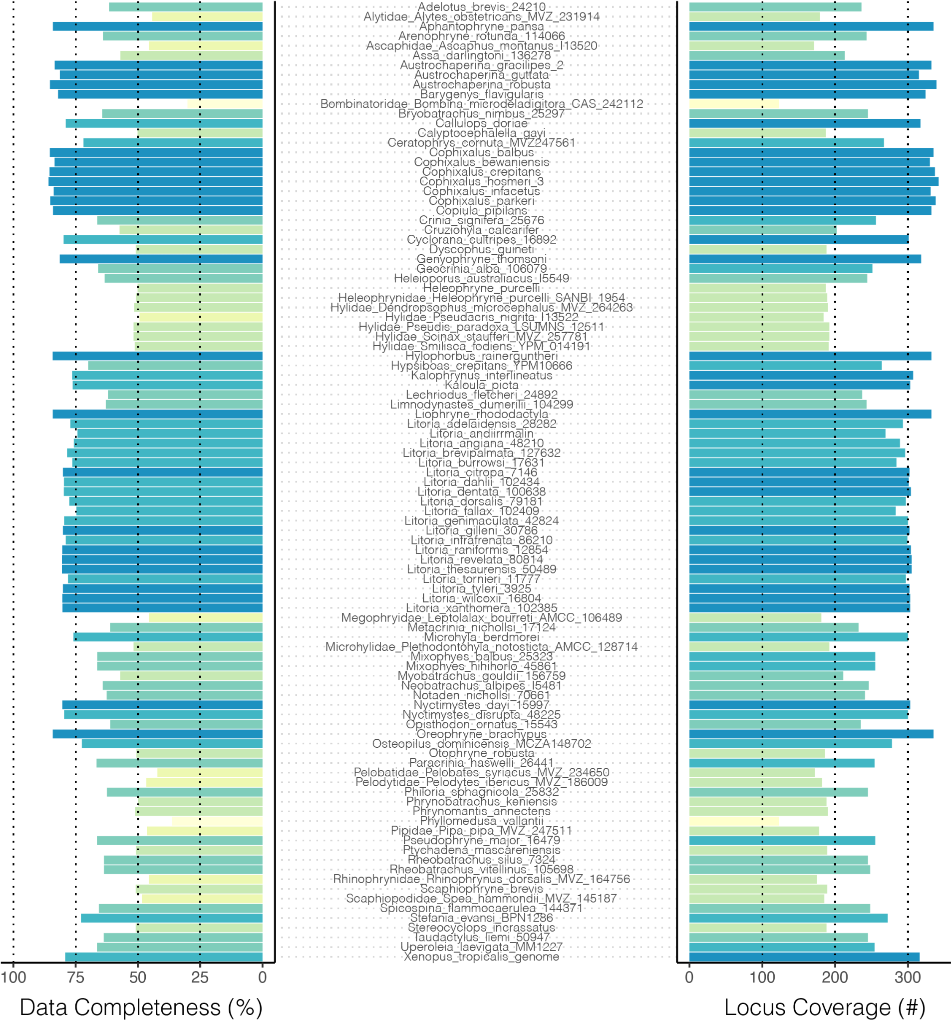

Figure S1. Data completeness across all samples. Left histogram shows data completeness as percent of bases in total alignment (concatenated alignment length 523,036 bp) exclusive of gaps (-) and missing bases (N). Right histogram shows data completeness as the absolute number of loci included per sample, as a representation of the number of gene trees per sample.

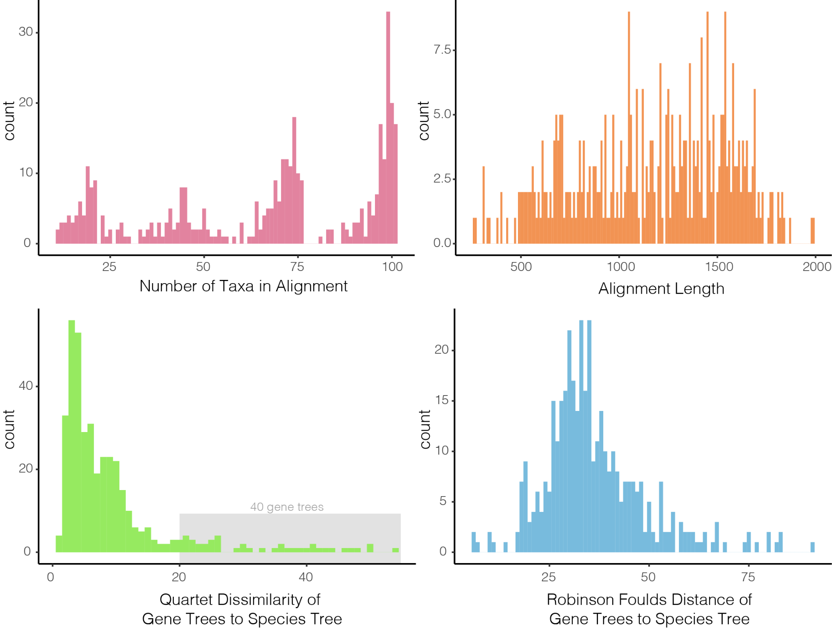

Figure S2. Basic summary statistics of the 450 locus alignments and gene trees. Top row shows histograms of the number of taxa in (max=101, min=11) and length of each alignment. Bottom row shows gene tree--species tree distances as quartet dissimilarity scores and Robinson Foulds distances, two different measures of topological similarity. Both quartet dissimilarity and RF scores are estimated by first subsetting the species tree to match gene tree sampling.

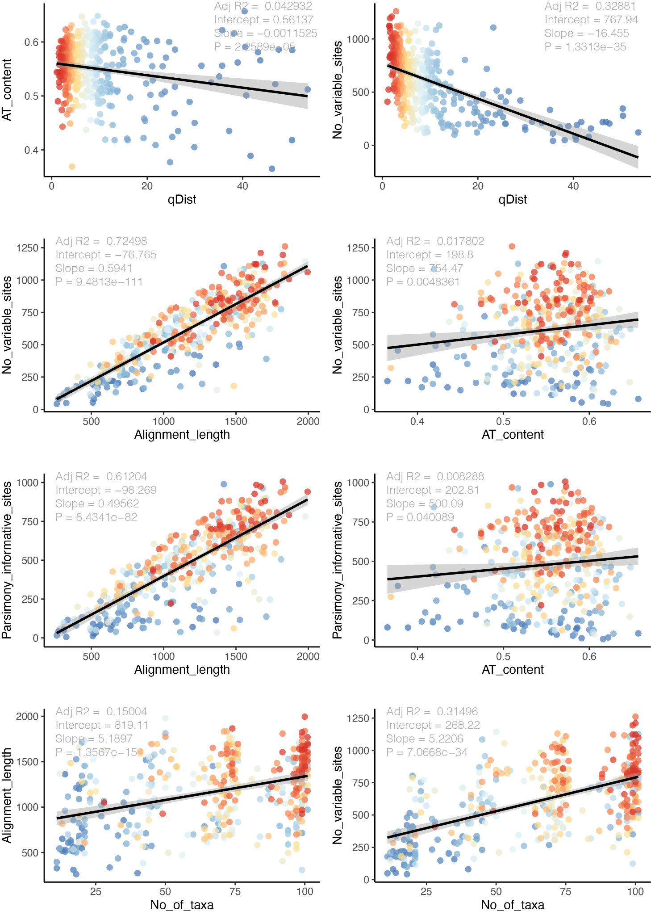

Figure S3. Detailed summary statistics of the 450 locus alignments and gene trees. Top row compares AT content and number of variable sites against quartet distance between each gene tree and the species tree (a measure of topological similarity). The second and third rows compare measures of locus informativeness (number of variable sites, number of parsimony informative sites) against alignment length and AT content. The bottom row shows alignment length and number of variable sites as a function of the number of taxa in the alignment. In all plots points (representing trees or alignments) are colored according to the quartet distance from the species tree.

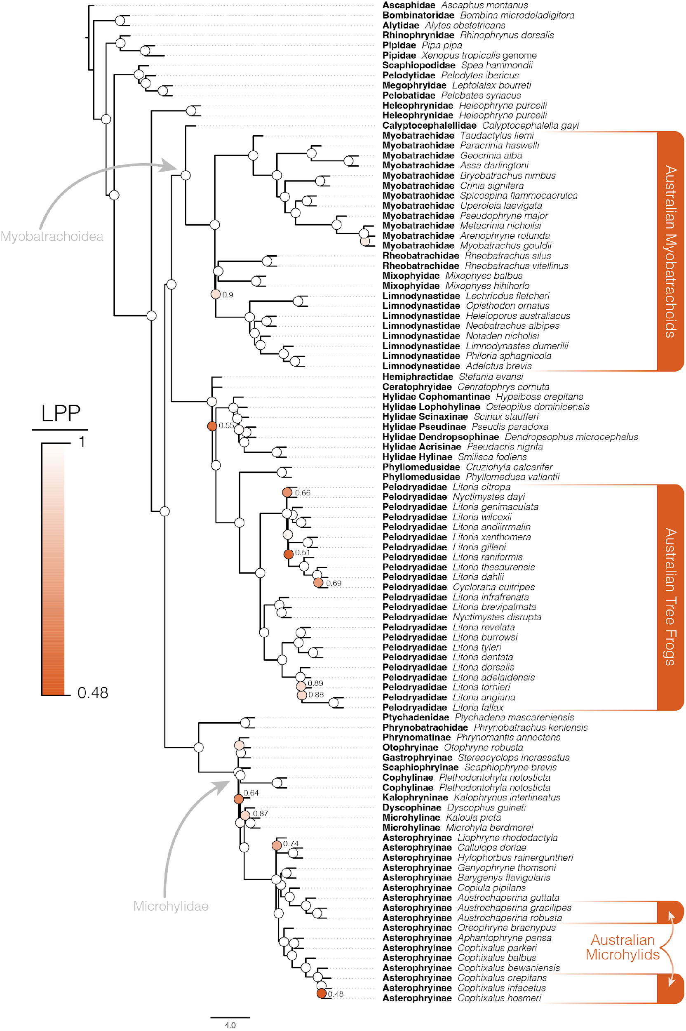

Figure S4. Species tree of Australian frogs and appropriate outgroup taxa estimated using ASTRAL with locus trees estimated by IQTREE as input. Phylogenetic resolution among major frog groups and within Australian frog clades is consistently high. Support values are shown at nodes and colored according to local posterior probabilities (LPP), values >0.9 are considered strongly supported and not indicated at nodes (white circles).

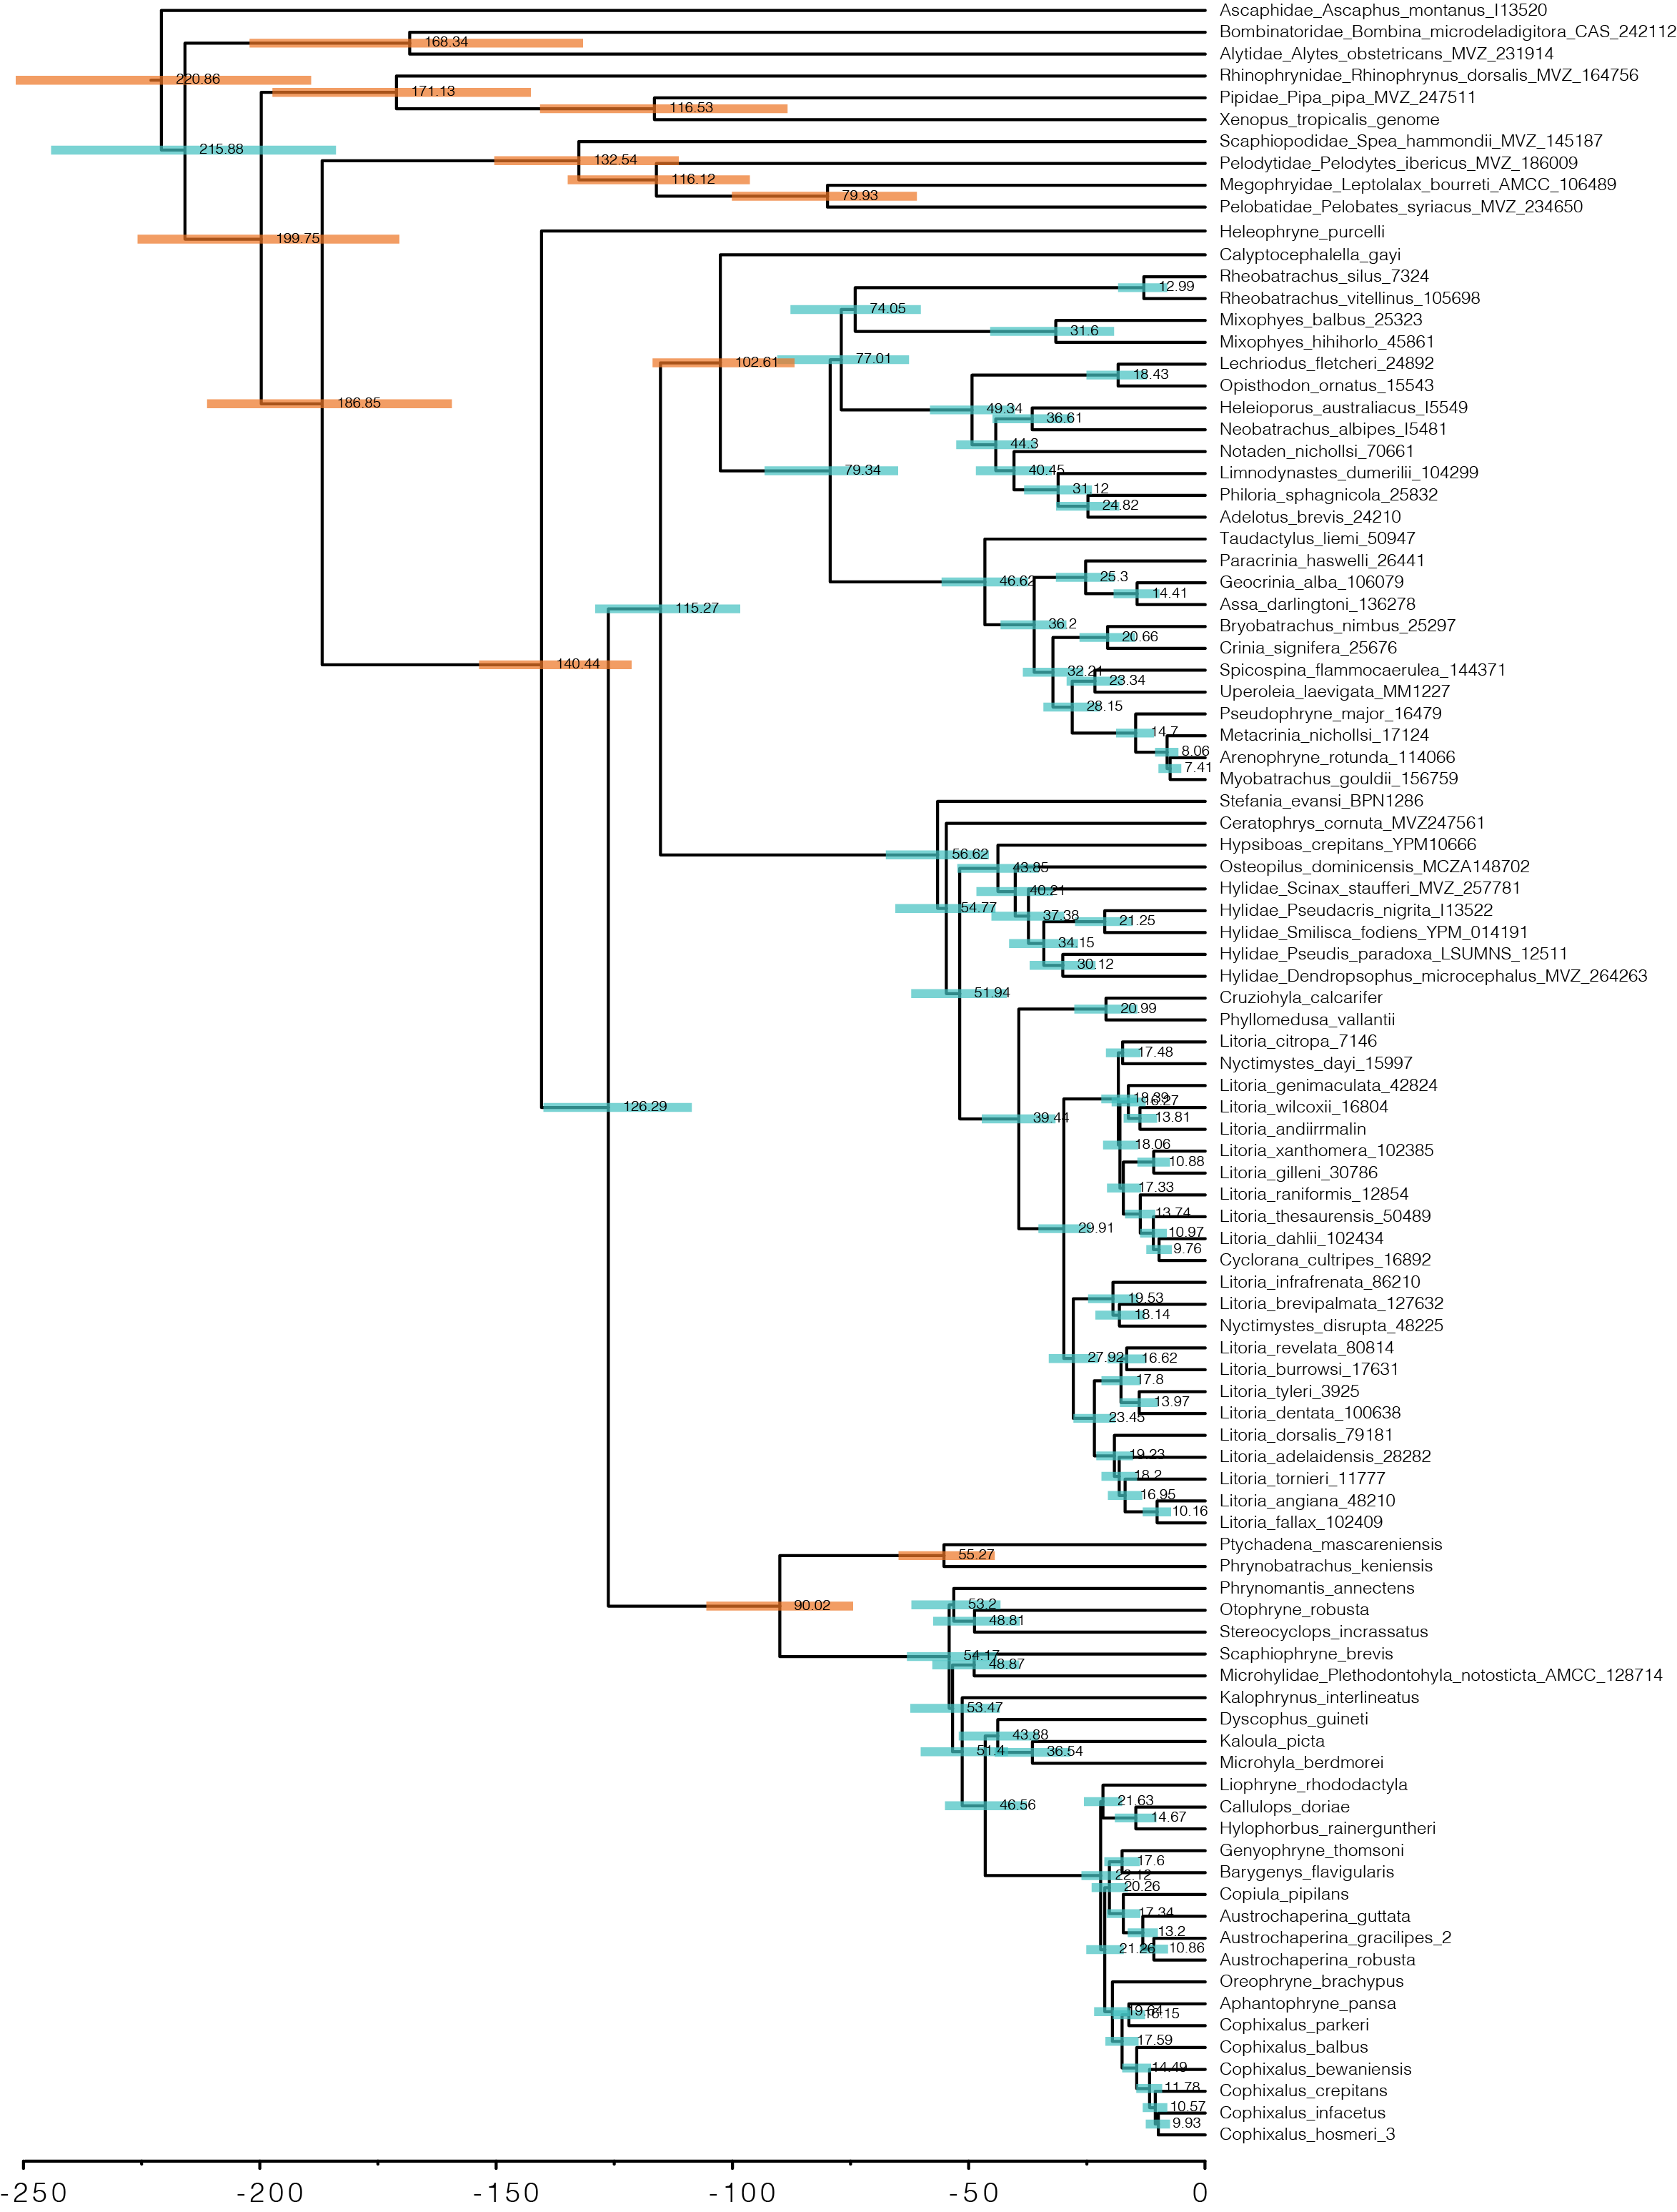

Figure S5. Species tree of Australian and outgroup frogs estimated with ASTRAL from IQTREE genetrees and time-calibrated with MCMCtree. Shaded bars at nodes indicate 95% confidence estimates on ages and numbers indicate mean age estimates. Orange shaded bars indicate nodes which were calibrated with from fossil evidence (see Table S2).